An Integrated Framework for Fairness Auditing, Bias Mitigation and Explainability in Responsible AI

Mayur Jadhav
Department of CMPN
Vidyalankar Institute of Technology
(Affiliated to University of Mumbai)
Mumbai, India
mayur.jadhav@vit.edu.in
Dr. Aniket Kundu
First Year Engineering
Vidyalankar Institute of Technology
(Affiliated to University of Mumbai)
Mumbai, India
aniket.kundu@vit.edu.in
Abstract—Responsible artificial intelligence requires that automated decisions be fair, explainable and open to audit, yet these three requirements are usually studied in isolation. This paper presents an integrated five-stage framework that links data definition, bias auditing, mitigation, explanation and governance review into one repeatable workflow. The framework is evaluated on a controlled synthetic lending dataset in which historical label bias and a proxy variable are planted deliberately, so that the true sources of unfairness are known. Over twenty independent runs, two classifiers (logistic regression and gradient boosting) and four mitigation strategies are compared using statistical parity difference, disparate impact and equal opportunity difference. Equal opportunity difference falls from about 0.10 to within 0.02 of zero for every strategy, at a cost of about 0.6 percentage points of accuracy or less, whereas statistical parity improves only partly and disparate impact stays near 0.5, below the four-fifths rule. Coefficient analysis further shows that reweighing removes most of the weight that the model places on a proxy feature. The results illustrate why a single fairness metric is insufficient and why explanation should accompany every mitigation step.
Keywords—Responsible AI, AI fairness, bias mitigation, explainable AI, algorithmic auditing, equal opportunity

Introduction
Machine learning systems now take part in decisions that shape access to credit, employment, education and healthcare. When such systems are trained on records that reflect past inequality, they can reproduce and even amplify it, often without any malicious intent on the part of their builders [1]. Documented cases include a commercial healthcare risk score that under-estimated the needs of Black patients because it used past spending as a stand-in for illness [2], and face-analysis products whose error rates differed sharply across skin tone and gender [3].
These cases have moved responsible AI from an ethical aspiration to an engineering and regulatory requirement. The NIST AI Risk Management Framework asks organisations to govern, map, measure and manage AI risks [4], and the European Union AI Act places data-governance, transparency and human-oversight duties on high-risk systems [5]. Practitioners therefore need methods that can be applied, measured and documented, and not only principles.
Three obstacles make this difficult. First, there is no single definition of fairness, and several popular definitions cannot hold at the same time except in degenerate cases [6], [7]. Second, deleting a protected attribute from the data does little when other variables encode it indirectly. Third, a model that is declared fair on one metric can still be unacceptable if nobody can say which inputs drive its decisions [8], [9]. Fairness, bias mitigation and explainability are therefore interdependent, yet most studies address only one of them at a time.
This paper makes the following contributions:
- an integrated five-stage framework that connects bias auditing, mitigation, explanation and governance review;
- a controlled synthetic benchmark in which label bias and a proxy variable are planted, so that the cause of every disparity is known;
- an empirical comparison, repeated over 20 random seeds, of four mitigation strategies on two model families using three complementary group-fairness metrics; and
- an explanation analysis showing how mitigation changes the weight that a model gives to a proxy feature, together with practical reporting guidance.
The rest of the paper is organised as follows. Section II reviews related work, Section III describes the framework, Section IV details the experimental design, Section V discusses the results, and Section VI concludes with open challenges.

Related Work

Definitions of Fairness
Group fairness criteria compare statistics of a classifier across demographic groups. Statistical parity requires equal rates of positive predictions, while equal opportunity and equalised odds, introduced by Hardt et al., compare error rates conditioned on the true outcome [10]. Individual fairness instead demands that similar individuals receive similar predictions [11]. Book-length treatments organise these notions together with their limitations [12]. Chouldechova and Kleinberg et al. showed that when base rates differ between groups, calibration and equal error rates cannot be satisfied together [7], [6], and Corbett-Davies and Goel argue that every criterion embeds assumptions that deserve scrutiny before adoption [13].

Bias Mitigation Techniques
Mitigation methods are commonly grouped by the point at which they intervene. Pre-processing methods change the training data; the reweighing scheme of Kamiran and Calders assigns instance weights so that the protected attribute and the label become statistically independent in the weighted data [14]. In-processing methods alter the learning objective, for example through adversarial training that discourages a predictor from revealing group membership [15]. Post-processing methods adjust outputs after training, such as group-specific decision thresholds that equalise true-positive rates [10]. Open-source toolkits such as AI Fairness 360 bundle many of these algorithms and metrics [16].

Explainability and Interpretability
Explainable AI (XAI) seeks to make model behaviour understandable to people [17], [18]. Post-hoc techniques such as LIME and SHAP attribute a prediction to input features [19], [20], whereas intrinsically interpretable models expose their reasoning directly. Lipton cautions that interpretability is not a single property and that claims about it must be made precise [8], and Rudin argues that for high-stakes decisions interpretable models should be preferred over explanations of black boxes [9]. Explanations are directly useful in fairness work because they can reveal whether a model leans on a proxy for a protected attribute.

Governance and Regulation
Technical measures operate inside a wider governance setting. The NIST framework organises risk activities under the functions govern, map, measure and manage [4], and the EU AI Act sets obligations in proportion to risk level [5]. Both assume that an organisation can produce evidence, such as metric reports and documented design choices. The framework proposed below is intended to generate exactly that kind of evidence.

Proposed Framework
Fig. 1 summarises the framework. It consists of five stages that are applied in order and revisited whenever the data or the model changes.
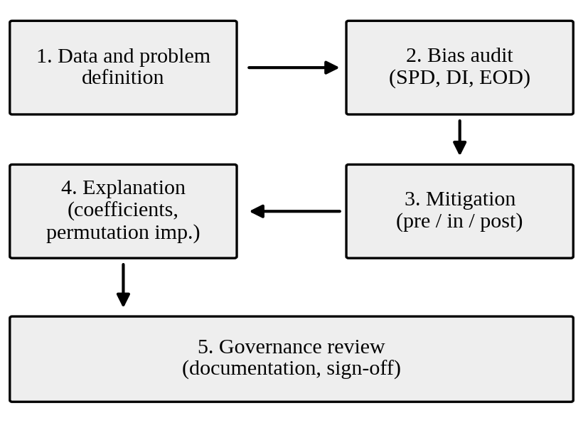
- Five-stage framework for responsible model development.

Stage 1: Data and Problem Definition
The team states the decision to be supported, identifies protected attributes and plausible proxies, and records how the labels were produced. Label provenance matters because labels that encode earlier human decisions carry the bias of those decisions, and a model can only learn what its labels contain.

Stage 2: Bias Audit
Let A denote the protected attribute, Y the true label and Ŷ the model decision, with A = 0 the reference group. Three group metrics are computed on held-out data. Statistical parity difference (SPD) is the gap in positive-decision rates:
SPD = P(Ŷ = 1 | A = 0) − P(Ŷ = 1 | A = 1) (1)
Disparate impact (DI) is the ratio of the same rates, and values below 0.8 are widely treated as a warning sign (the four-fifths rule):
DI = P(Ŷ = 1 | A = 1) / P(Ŷ = 1 | A = 0) (2)
Equal opportunity difference (EOD) compares true-positive rates:
EOD = P(Ŷ = 1 | A = 0, Y = 1) − P(Ŷ = 1 | A = 1, Y = 1) (3)
Positive SPD and EOD values mean that the reference group is favoured. SPD and DI describe outcomes irrespective of merit, whereas EOD asks whether equally qualified people are treated equally. Reporting all three prevents a single number from hiding a trade-off.

Stage 3: Bias Mitigation
Four strategies are examined. Drop proxy removes the suspected proxy feature. Reweighing is a pre-processing method that gives each training instance the weight
w(a, y) = P(A = a) · P(Y = y) / P(A = a, Y = y) (4)
which up-weights combinations of group and label that are under-represented relative to statistical independence [14]. Threshold EO is a post-processing step that chooses a separate decision threshold t_{a} for each group on a validation set, so that the true-positive rate of every group equals a common target τ, taken as the overall true-positive rate of the unadjusted model at a threshold of 0.5 [10]. Reweigh+EO applies reweighing first and threshold adjustment second. Because threshold adjustment uses group membership at decision time, it may be restricted in some jurisdictions and should be reviewed against the applicable legal framework.

Stage 4: Explanation
After mitigation, the model is explained globally with standardised logistic-regression coefficients and with permutation importance, defined as the drop in test AUC when a feature is shuffled. The purpose is to check that the mitigated model no longer relies on proxies and that its remaining drivers are defensible business factors. Local explanation tools [19], [20] can be added for individual decisions.

Stage 5: Governance Review
Metrics, a description of the data, mitigation choices and explanation findings are written into a model record that a reviewer outside the development team signs off, in line with the documentation and oversight themes of [4], [5]. The record also states which fairness criterion was prioritised and why, and defines the triggers for a repeat audit.

Experimental Setup

Synthetic Dataset
A synthetic loan-approval dataset is used so that the mechanism of bias is known exactly, which is not possible with real records. Each run draws 20,000 applicants, of whom about 39% belong to group 1, the unprivileged group. Six features are generated: income (in thousands), credit score, years of employment, debt ratio, loan amount and a neighbourhood zone index. For group 1 the mean income is five units lower, the mean credit score ten points lower and the mean employment history 0.7 years shorter, while the mean debt ratio is 0.04 higher. The zone index equals the group indicator plus Gaussian noise with a standard deviation of 0.6, which makes it a proxy with a correlation of about 0.63 with group membership. A latent merit score is computed from the legitimate features, and an application is labelled approved when the merit score plus noise, minus a penalty of 0.55 for group 1, exceeds a fixed cut-off. The penalty represents historical bias in past decisions. In a representative draw the approval rate is 36.9% for group 0 and 14.0% for group 1. The protected attribute itself is never given to a classifier as an input.

Models and Protocol
Two model families are used: L2-regularised logistic regression with default regularisation strength, and histogram-based gradient boosting with 150 boosting rounds and a learning rate of 0.1, both from scikit-learn [21]. Features are standardised using training statistics. Each dataset is split into training (52.5%), validation (17.5%) and test (30%) portions, stratified by group and label. The validation portion is used only to choose group thresholds. All metrics are computed on the test portion, and the whole experiment is repeated for 20 random seeds, each of which regenerates the data. The tables report means over the 20 runs, and the text gives standard deviations where relevant.

Evaluation Metrics
Accuracy and the area under the ROC curve (AUC) measure predictive utility. SPD, DI and EOD from Section III-B measure fairness. Predicted probabilities are converted to decisions with a threshold of 0.5 except where group thresholds are tuned.

Results and Discussion

Effect on Group Fairness
Tables I and II show clear disparities in the unmitigated models. SPD is 0.187 for logistic regression and 0.185 for gradient boosting, DI is 0.39 and 0.41, and EOD is about 0.10 in both cases. A positive EOD means that qualified applicants from group 1 are approved less often than equally qualified applicants from group 0, which is consistent with the planted label bias and with the use of the zone proxy.
- Logistic Regression Results (Mean of 20 Runs)
Method | Acc. | AUC | SPD | DI | EOD
Baseline | 0.843 | 0.903 | 0.187 | 0.393 | 0.103
Drop proxy | 0.841 | 0.900 | 0.143 | 0.505 | 0.012
Reweighing | 0.840 | 0.899 | 0.131 | 0.536 | −0.015
Threshold EO | 0.838 | 0.903 | 0.146 | 0.508 | 0.015
Reweigh+EO | 0.842 | 0.899 | 0.143 | 0.501 | 0.013

- Gradient Boosting Results (Mean of 20 Runs)
Method | Acc. | AUC | SPD | DI | EOD
Baseline | 0.836 | 0.893 | 0.185 | 0.411 | 0.102
Drop proxy | 0.832 | 0.890 | 0.140 | 0.527 | 0.003
Reweighing | 0.832 | 0.890 | 0.139 | 0.521 | 0.006
Threshold EO | 0.830 | 0.893 | 0.139 | 0.538 | 0.004
Reweigh+EO | 0.832 | 0.890 | 0.136 | 0.531 | 0.000

Every mitigation strategy brings EOD to between −0.015 and 0.015 in all eight model–strategy combinations, as Fig. 2 shows. The standard deviation of EOD across seeds after mitigation is between 0.028 and 0.046, so differences among the strategies are smaller than the run-to-run variation. Statistical parity improves much less. SPD declines to 0.131–0.146 for logistic regression and 0.136–0.140 for gradient boosting, and DI rises only to the range 0.50–0.54, well below 0.8.
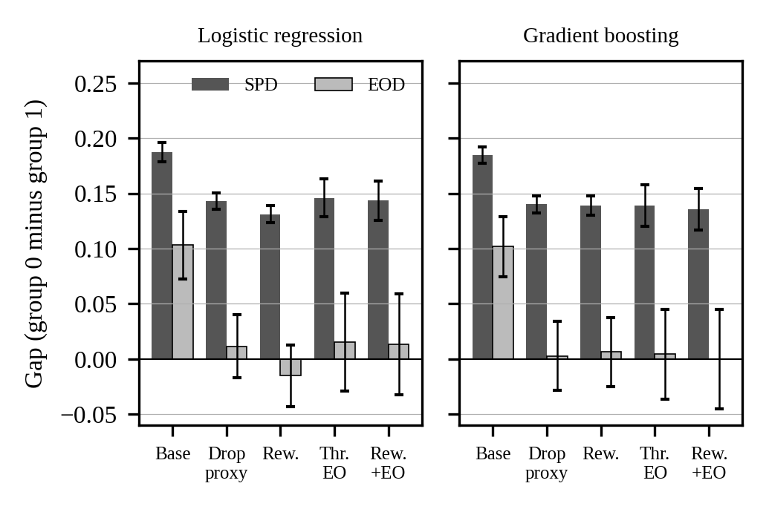
- Statistical parity difference (SPD) and equal opportunity difference (EOD) before and after mitigation. Bars show means over 20 runs; error bars show one standard deviation.
This is expected rather than a failure of the methods. Because the underlying approval rates differ, a classifier that treats equally qualified people equally will still approve different shares of each group, and the impossibility results cited earlier show that parity of outcomes and parity of error rates cannot both be reached when base rates differ [6], [7]. Which criterion should take priority is a policy decision that the governance stage must record, rather than a technical question that an algorithm can settle.

Accuracy–Fairness Trade-off
Mitigation costs little predictive utility. For logistic regression, accuracy moves from 0.843 to between 0.838 and 0.842, and AUC from 0.903 to 0.899–0.900 for the strategies that change the model, while threshold adjustment leaves AUC unchanged because it affects only decisions. For gradient boosting, accuracy moves from 0.836 to between 0.830 and 0.832. The largest accuracy loss observed is about 0.6 percentage points, so in this setting the price of equal opportunity is small.
Dropping the proxy was about as effective as reweighing on EOD. This holds only because the proxy here is a single known column. In real data proxies are many and diffuse, so removal alone cannot be relied upon [12], which is why the audit and explanation stages remain necessary.

What the Explanations Reveal
The baseline logistic regression gives the zone index a standardised coefficient of −0.32, so applicants with higher zone values, which are associated with group 1, are penalised even when all other features are equal (Fig. 3). After reweighing, the coefficient falls in magnitude to +0.06, a reduction of about 82%, while the coefficients of the five legitimate features change by at most 0.03. Permutation importance tells the same story: shuffling the zone index lowers test AUC by 0.007 for the baseline model but has no measurable effect (−0.001) after reweighing. Without this step, an auditor would see only a lower EOD and could not tell whether the model had stopped using the proxy.
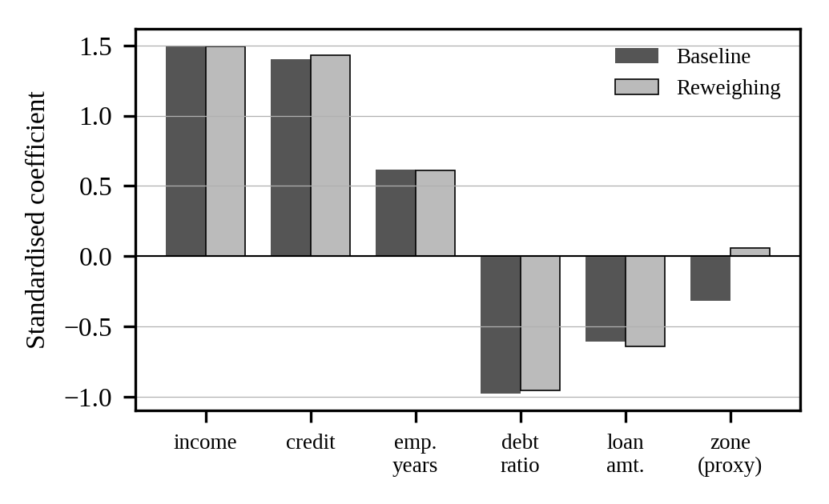
- Standardised logistic-regression coefficients before and after reweighing. The proxy (zone) coefficient shrinks towards zero while legitimate features keep their weights.

Limitations
The study has several limitations. The data are synthetic, so the absolute numbers should not be transferred to real lending systems; the value lies in the comparative behaviour under known bias. Only one binary protected attribute and one proxy are considered, whereas real systems face intersecting attributes [3]. EOD is computed against labels that carry the planted bias, so a low EOD indicates consistency with those labels and not the absence of discrimination [12]. Finally, in-processing methods such as adversarial debiasing [15] and local explanation tools were not evaluated, and the run-to-run variation of EOD (standard deviation up to 0.05) means that small differences between strategies should not be over-interpreted.

Conclusion and Future Work
This paper treated fairness auditing, bias mitigation and explainability as stages of one workflow rather than as separate topics. On a synthetic benchmark with known sources of bias, simple mitigation strategies removed most of the equal-opportunity gap at a very small cost in accuracy, but did not close the gap in overall approval rates, and only the explanation analysis showed that the model had stopped relying on a proxy variable. Three practical recommendations follow. Report several fairness metrics together and state which one is prioritised. Verify proxy use with explanations instead of relying on a single metric. Record every decision in a reviewable model record and re-audit when data or models change.
Several directions remain. Fairness must be combined with privacy, because models trained on sensitive data can leak information, and differential privacy [22] and federated learning [23] protect individuals in ways that interact with group fairness and still need careful study. Security matters as well, since adversarially crafted inputs can manipulate model decisions [24] and could be used to evade an audit. Future work will extend the framework to public real-world datasets, intersectional groups, in-processing methods and generative models.

Acknowledgment
The author thanks the Department of CMPN, Vidyalankar Institute of Technology, for academic support during this work.

References
- N. Mehrabi, F. Morstatter, N. Saxena, K. Lerman, and A. Galstyan, “A survey on bias and fairness in machine learning,” ACM Comput. Surv., vol. 54, no. 6, pp. 1–35, Jul. 2021.
- Z. Obermeyer, B. Powers, C. Vogeli, and S. Mullainathan, “Dissecting racial bias in an algorithm used to manage the health of populations,” Science, vol. 366, no. 6464, pp. 447–453, Oct. 2019.
- J. Buolamwini and T. Gebru, “Gender shades: Intersectional accuracy disparities in commercial gender classification,” in Proc. Conf. Fairness, Accountability and Transparency, PMLR 81, 2018, pp. 77–91.
- National Institute of Standards and Technology, “Artificial Intelligence Risk Management Framework (AI RMF 1.0),” NIST AI 100-1, Gaithersburg, MD, USA, Jan. 2023.
- European Parliament and Council of the European Union, “Regulation (EU) 2024/1689 laying down harmonised rules on artificial intelligence (Artificial Intelligence Act),” Off. J. Eur. Union, Jul. 2024.
- J. Kleinberg, S. Mullainathan, and M. Raghavan, “Inherent trade-offs in the fair determination of risk scores,” in Proc. 8th Innov. Theor. Comput. Sci. Conf., 2017, pp. 43:1–43:23.
- A. Chouldechova, “Fair prediction with disparate impact: A study of bias in recidivism prediction instruments,” Big Data, vol. 5, no. 2, pp. 153–163, Jun. 2017.
- Z. C. Lipton, “The mythos of model interpretability,” Commun. ACM, vol. 61, no. 10, pp. 36–43, Oct. 2018.
- C. Rudin, “Stop explaining black box machine learning models for high stakes decisions and use interpretable models instead,” Nature Mach. Intell., vol. 1, no. 5, pp. 206–215, May 2019.
- M. Hardt, E. Price, and N. Srebro, “Equality of opportunity in supervised learning,” in Adv. Neural Inf. Process. Syst. 29, 2016, pp. 3315–3323.
- C. Dwork, M. Hardt, T. Pitassi, O. Reingold, and R. Zemel, “Fairness through awareness,” in Proc. 3rd Innov. Theor. Comput. Sci. Conf., 2012, pp. 214–226.
- S. Barocas, M. Hardt, and A. Narayanan, Fairness and Machine Learning: Limitations and Opportunities. Cambridge, MA, USA: MIT Press, 2023.
- S. Corbett-Davies and S. Goel, “The measure and mismeasure of fairness: A critical review of fair machine learning,” 2018, arXiv:1808.00023.
- F. Kamiran and T. Calders, “Data preprocessing techniques for classification without discrimination,” Knowl. Inf. Syst., vol. 33, no. 1, pp. 1–33, Oct. 2012.
- B. H. Zhang, B. Lemoine, and M. Mitchell, “Mitigating unwanted biases with adversarial learning,” in Proc. AAAI/ACM Conf. AI, Ethics, and Society, 2018, pp. 335–340.
- R. K. E. Bellamy et al., “AI Fairness 360: An extensible toolkit for detecting and mitigating algorithmic bias,” IBM J. Res. Dev., vol. 63, no. 4/5, pp. 4:1–4:15, 2019.
- A. Barredo Arrieta et al., “Explainable artificial intelligence (XAI): Concepts, taxonomies, opportunities and challenges toward responsible AI,” Inf. Fusion, vol. 58, pp. 82–115, Jun. 2020.
- R. Guidotti, A. Monreale, S. Ruggieri, F. Turini, F. Giannotti, and D. Pedreschi, “A survey of methods for explaining black box models,” ACM Comput. Surv., vol. 51, no. 5, pp. 1–42, Sep. 2018.
- M. T. Ribeiro, S. Singh, and C. Guestrin, “‘Why should I trust you?’: Explaining the predictions of any classifier,” in Proc. 22nd ACM SIGKDD Int. Conf. Knowl. Discovery Data Mining, 2016, pp. 1135–1144.
- S. M. Lundberg and S.-I. Lee, “A unified approach to interpreting model predictions,” in Adv. Neural Inf. Process. Syst. 30, 2017, pp. 4765–4774.
- F. Pedregosa et al., “Scikit-learn: Machine learning in Python,” J. Mach. Learn. Res., vol. 12, pp. 2825–2830, 2011.
- C. Dwork and A. Roth, “The algorithmic foundations of differential privacy,” Found. Trends Theor. Comput. Sci., vol. 9, no. 3–4, pp. 211–407, 2014.
- B. McMahan, E. Moore, D. Ramage, S. Hampson, and B. A. y Arcas, “Communication-efficient learning of deep networks from decentralized data,” in Proc. 20th Int. Conf. Artif. Intell. Statist., PMLR 54, 2017, pp. 1273–1282.
- I. J. Goodfellow, J. Shlens, and C. Szegedy, “Explaining and harnessing adversarial examples,” in Proc. Int. Conf. Learn. Represent., 2015, arXiv:1412.6572.

